Unit Circle
# Source: AI Source: Provided by: [Data Path: Persons Table -> ID Column: 1, Name_En Column: Motasem Essam] -> From: [ChatGPT] on [7/25/2026]
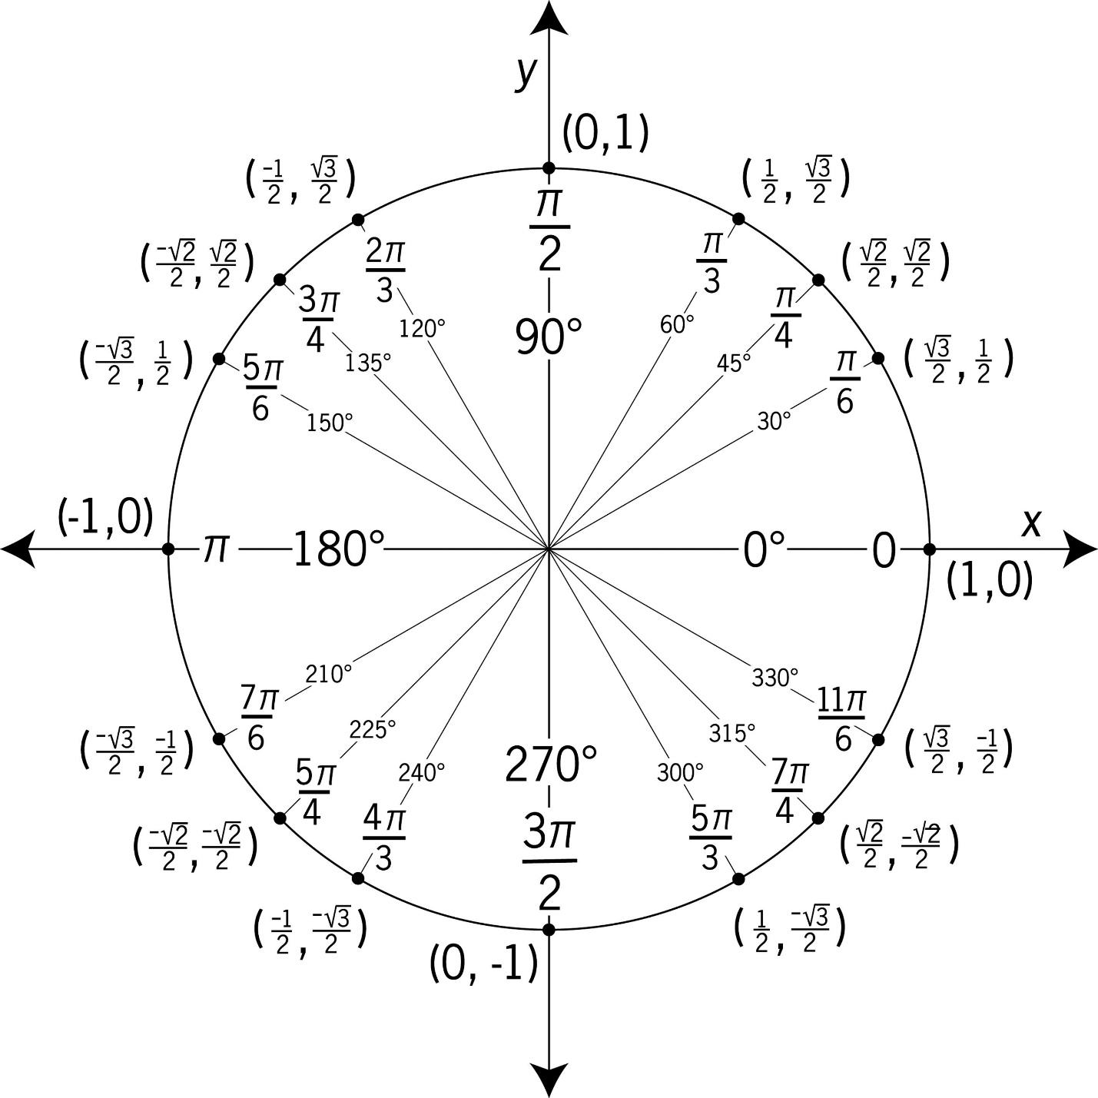
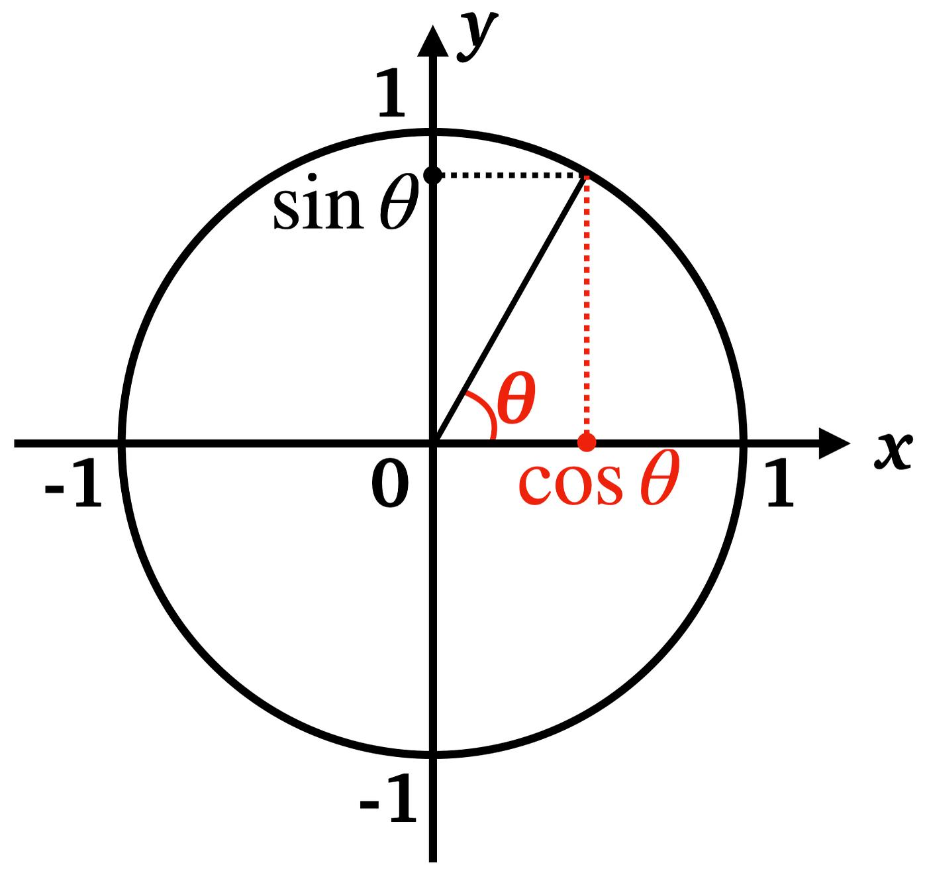
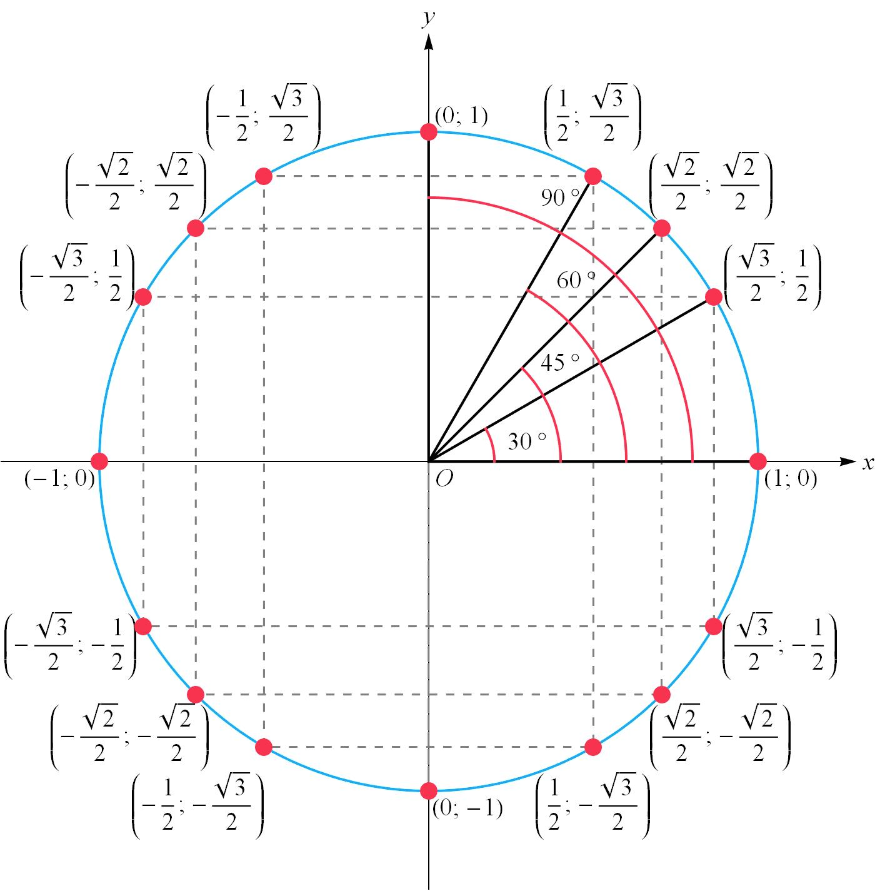
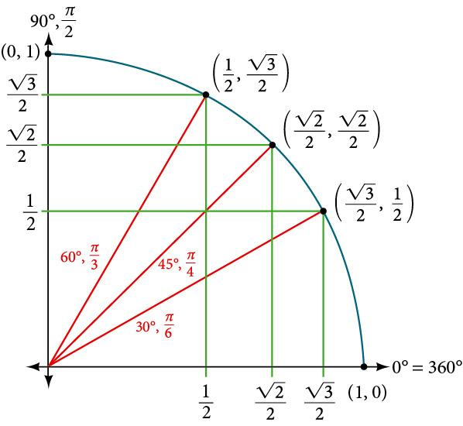
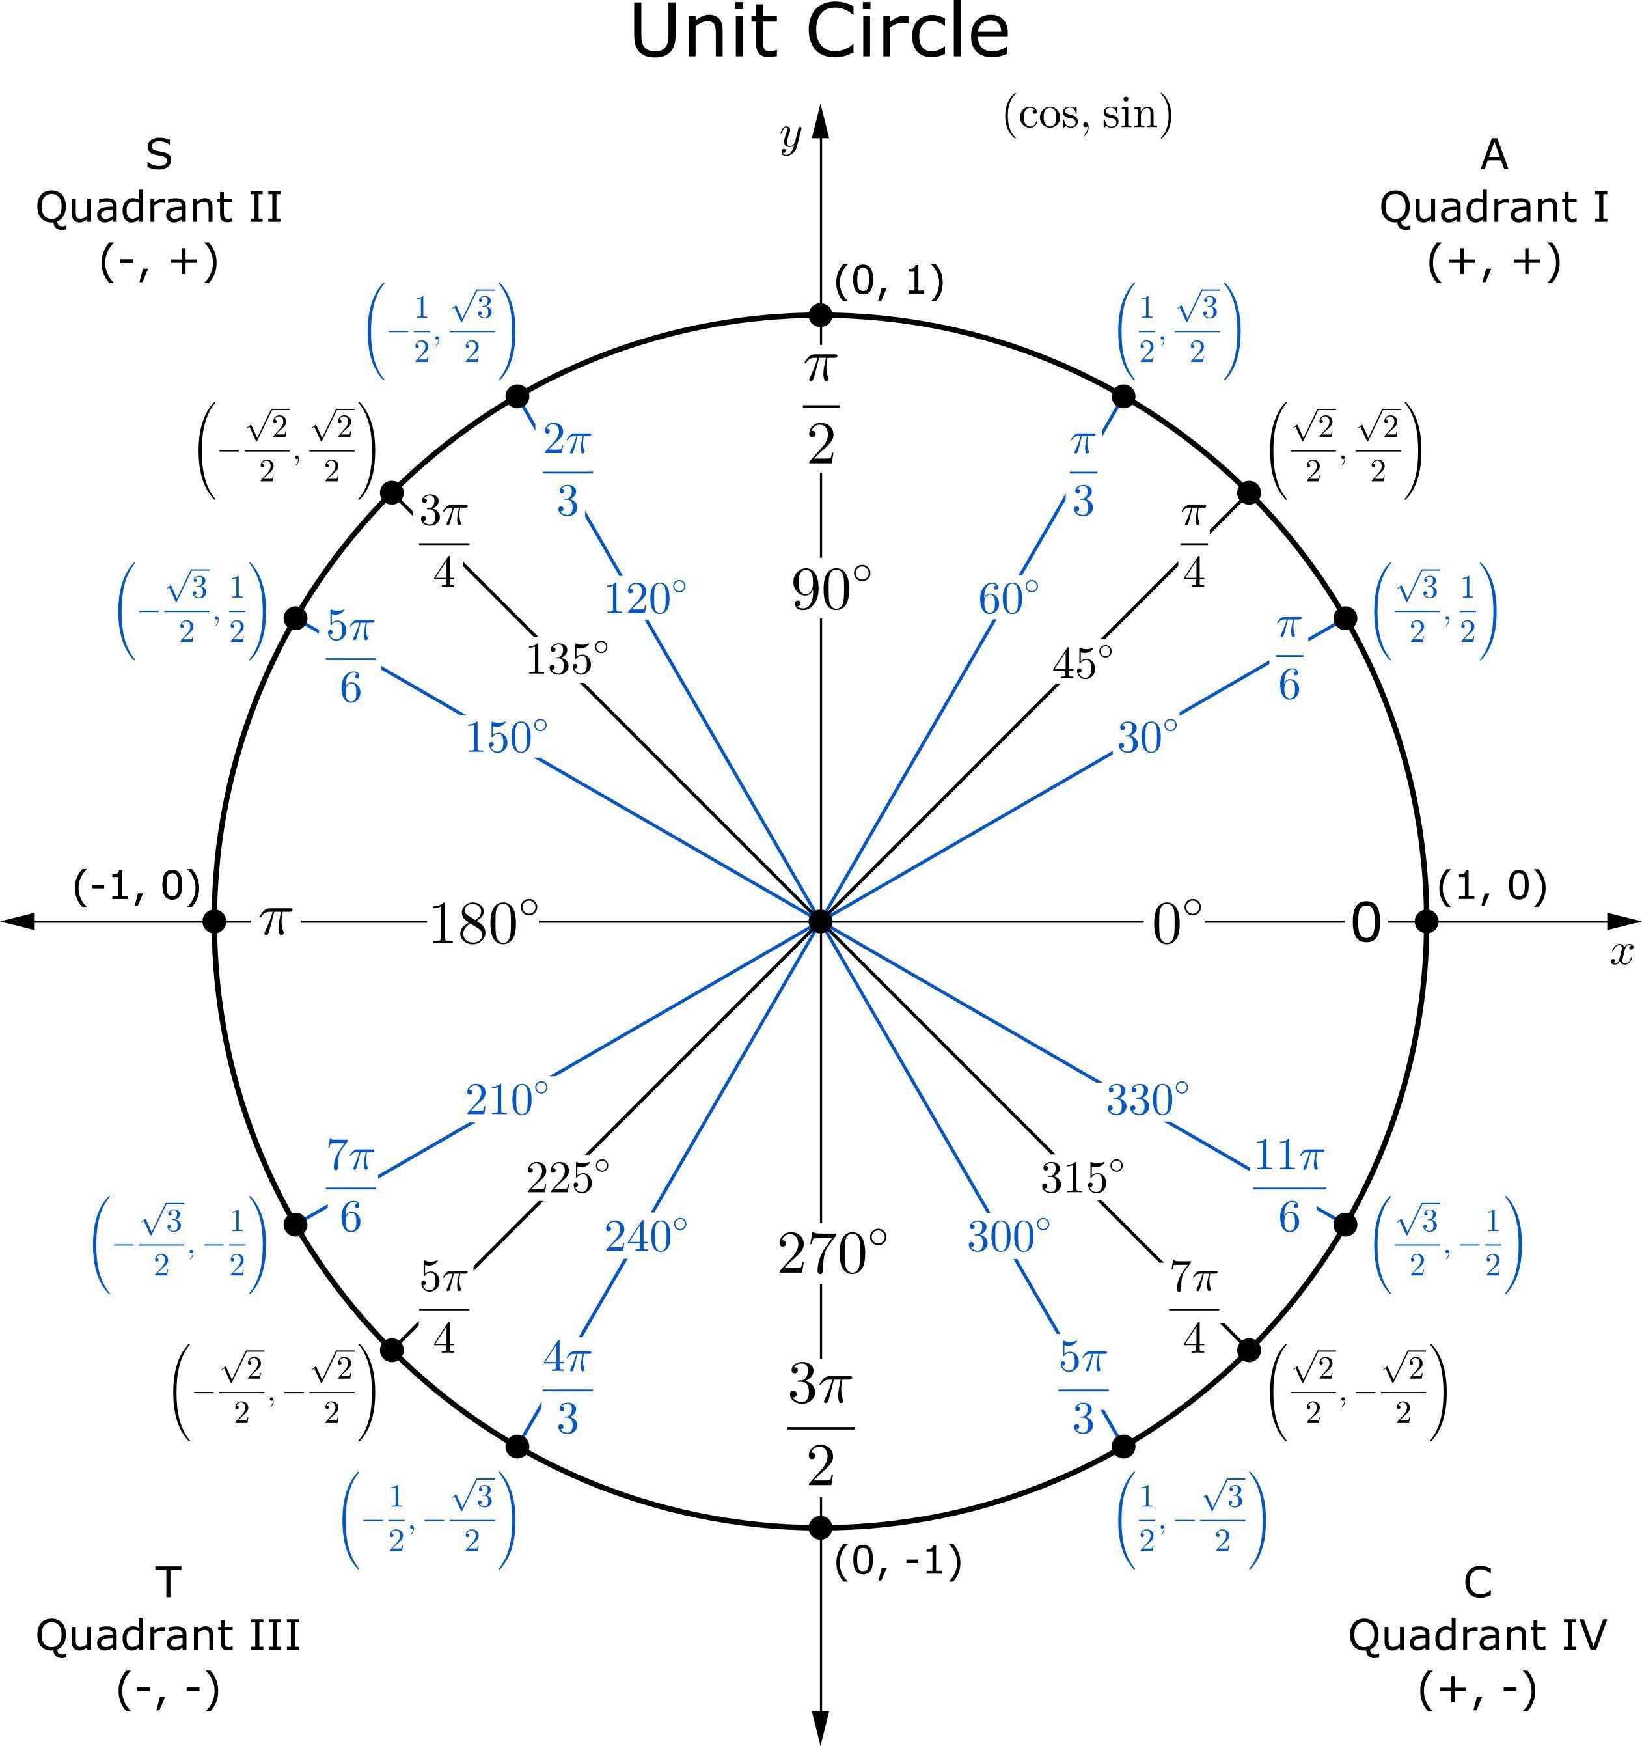
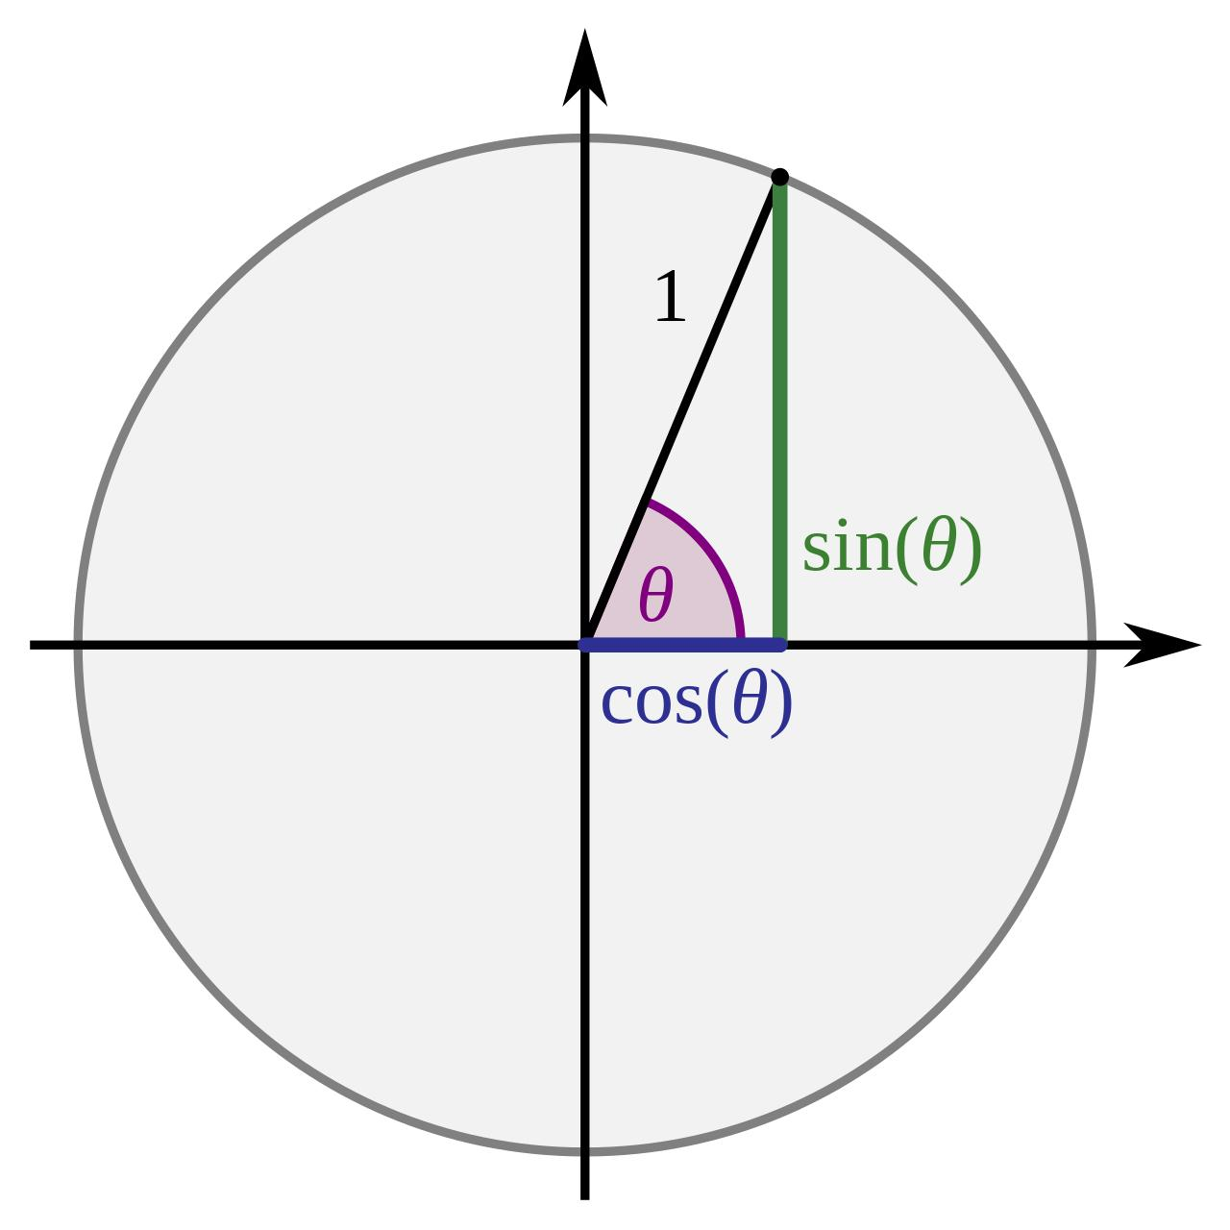

Definition
# Source: AI Source: Provided by: [Data Path: Persons Table -> ID Column: 1, Name_En Column: Motasem Essam] -> From: [ChatGPT] on [7/25/2026]
A Unit Circle is a circle with a radius of exactly 1 unit.
The standard unit circle is centered at the origin of the Cartesian coordinate system:
$$O=\left(0 , 0\right)$$
Its equation is:
$$\boxed{x^{2}+y^{2}=1}$$
The term unit indicates that the radius is $1$.

Fundamental Concept
# Source: AI Source: Provided by: [Data Path: Persons Table -> ID Column: 1, Name_En Column: Motasem Essam] -> From: [ChatGPT] on [7/25/2026]
The Unit Circle provides a geometric representation of the trigonometric functions sine, cosine, and tangent.
For an angle $θ$, a point $P=\left(x , y\right)$on the Unit Circle is:
$$\boxed{P=\left(\cos{θ} , \sin{θ}\right)}$$
Therefore:
$$\boxed{x=\cos{θ}}$$
and
$$\boxed{y=\sin{θ}}$$
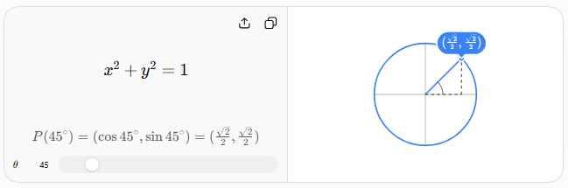

Basic Structure
# Source: AI Source: Provided by: [Data Path: Persons Table -> ID Column: 1, Name_En Column: Motasem Essam] -> From: [ChatGPT] on [7/25/2026]
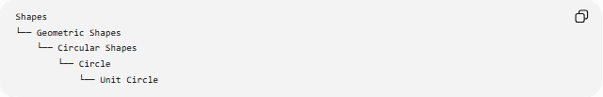
Shapes
└── Geometric Shapes
└── Circular Shapes
└── Circle
└── Unit Circle
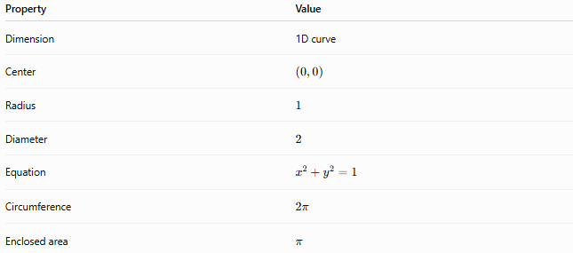
Property | Value
Dimension | 1D curve
Center | $$\left(0 , 0\right)$$
Radius | $$1$$
Diameter | $$2$$
Equation | $$x^{2}+y^{2}=1$$
Circumference | $$2π$$
Enclosed area | $$π$$

Mathematical Representation
# Source: AI Source: Provided by: [Data Path: Persons Table -> ID Column: 1, Name_En Column: Motasem Essam] -> From: [ChatGPT] on [7/25/2026]
Cartesian Equation
The standard equation is:
$$\boxed{x^{2}+y^{2}=1}$$
Parametric Representation
A point moving around the Unit Circle can be represented by:
$$\boxed{x=\cos{θ}} \\ \boxed{y=\sin{θ}}$$
Therefore:
$$\boxed{P\left(θ\right)=\left(\cos{θ} , \sin{θ}\right)}$$
For one complete revolution:
$$0≤θ<2π$$
Polar Representation
The radius is always $1$:
$$\boxed{r=1}$$

Important Points
# Source: AI Source: Provided by: [Data Path: Persons Table -> ID Column: 1, Name_En Column: Motasem Essam] -> From: [ChatGPT] on [7/25/2026]
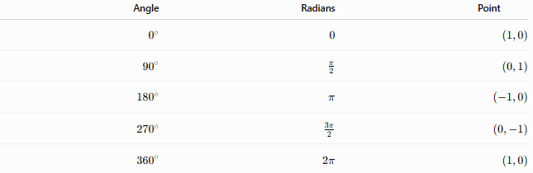
Angle | Radians | Point
$$0^{∘}$$ | $$0$$ | $$\left(1 , 0\right)$$
$${90}^{∘}$$ | $$\frac{π}{2}$$ | $$\left(0 , 1\right)$$
$${180}^{∘}$$ | $$π$$ | $$\left(- , 10\right)$$
$${270}^{∘}$$ | $$\frac{3π}{2}$$ | $$\left(0 , -1\right)$$
$${360}^{∘}$$ | $$2π$$ | $$\left(1 , 0\right)$$
These points divide the Unit Circle into four quadrants.

Special Angles
# Source: AI Source: Provided by: [Data Path: Persons Table -> ID Column: 1, Name_En Column: Motasem Essam] -> From: [ChatGPT] on [7/25/2026]
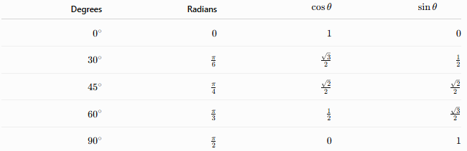
Degrees | Radians | $$\cos{θ}$$ | $$\sin{θ}$$
$$0^{∘}$$ | $$0$$ | $$1$$ | $$0$$
$${30}^{∘}$$ | $$\frac{π}{6}$$ | $$\frac{\sqrt{3}}{2}$$ | $$\frac{1}{2}$$
$${45}^{∘}$$ | $$\frac{π}{4}$$ | $$\frac{\sqrt{2}}{2}$$ | $$\frac{\sqrt{2}}{2}$$
$${60}^{∘}$$ | $$\frac{π}{3}$$ | $$\frac{1}{2}$$ | $$\frac{\sqrt{3}}{2}$$
$${90}^{∘}$$ | $$\frac{π}{2}$$ | $$0$$ | $$1$$
These values can be extended to the other quadrants by applying the appropriate signs.

Quadrants
# Source: AI Source: Provided by: [Data Path: Persons Table -> ID Column: 1, Name_En Column: Motasem Essam] -> From: [ChatGPT] on [7/25/2026]
Quadrant I
$$0^{∘}<θ<{90}^{∘} \\ x>0, y>0$$
Therefore:
$$\sin{θ}>0, \cos{θ}>0$$
Quadrant II
$${90}^{∘}<θ<{180}^{∘} \\ x<0, y>0$$
Therefore:
$$\sin{θ}>0, \cos{θ}<0$$
Quadrant III
$${180}^{∘}<θ<{270}^{∘} \\ x<0, y<0$$
Therefore:
$$\sin{θ}<0, \cos{θ}<0$$
Quadrant IV
$${270}^{∘}<θ<{360}^{∘} \\ x>0, y<0$$
Therefore:
$$\sin{θ}<0, \cos{θ}>0$$

Trigonometric Functions
# Source: AI Source: Provided by: [Data Path: Persons Table -> ID Column: 1, Name_En Column: Motasem Essam] -> From: [ChatGPT] on [7/25/2026]
For a point
$$P=\left(x , y\right)=\left(\cos{θ} , \sin{θ}\right)$$
on the Unit Circle:
Sine
$$\boxed{\sin{θ}=y}$$
Cosine
$$\boxed{\cos{θ}=x}$$
Tangent
$$\tan{θ}=\frac{\sin{θ}}{\cos{θ}}$$
Therefore:
$$\boxed{\tan{θ}=\frac{y}{x}}$$
provided that $x≠0$.

Fundamental Trigonometric Identity
# Source: AI Source: Provided by: [Data Path: Persons Table -> ID Column: 1, Name_En Column: Motasem Essam] -> From: [ChatGPT] on [7/25/2026]
Every point on the Unit Circle satisfies:
$$x^{2}+y^{2}=1$$
Substituting
$$x=\cos{θ}$$
and
$$y=\sin{θ}$$
gives:
$$\boxed{\sin^{2}θ+\cos^{2}θ=1}$$
This is the fundamental Pythagorean identity of trigonometry.

Circumference and Enclosed Area
# Source: AI Source: Provided by: [Data Path: Persons Table -> ID Column: 1, Name_En Column: Motasem Essam] -> From: [ChatGPT] on [7/25/2026]
Circumference
Since $r=1$:
$$C=2πr \\ \boxed{C=2π}$$
Enclosed Area
The area enclosed by the Unit Circle is:
$$A=πr^{2}$$
Therefore:
$$\boxed{A=π}$$
The distinction is important: the Unit Circle itself is the boundary curve, while the enclosed filled region is the Unit Disk.

Arc Length
# Source: AI Source: Provided by: [Data Path: Persons Table -> ID Column: 1, Name_En Column: Motasem Essam] -> From: [ChatGPT] on [7/25/2026]
For an angle $θ$measured in radians:
$$s=rθ$$
Since the Unit Circle has $r=1$:
$$\boxed{s=θ}$$
Thus, on the Unit Circle, the numerical value of an angle in radians equals the length of its corresponding arc.
For example:
$$θ=\frac{π}{2}$$
gives:
$$\boxed{s=\frac{π}{2}}$$

Symmetry
# Source: AI Source: Provided by: [Data Path: Persons Table -> ID Column: 1, Name_En Column: Motasem Essam] -> From: [ChatGPT] on [7/25/2026]
The Unit Circle has extensive symmetry.
Reflection Symmetry
It is symmetric about:
- the $x$-axis,
- the $y$-axis,
- every line passing through the origin.
Rotational Symmetry
It remains unchanged under every rotation about the origin.
Therefore, it has continuous rotational symmetry.
Point Symmetry
A ${180}^{∘}$rotation about the origin maps:
$$\left(x , y\right)→\left(- , x-y\right)$$
and leaves the Unit Circle unchanged.

Unit Circle vs Circle
# Source: AI Source: Provided by: [Data Path: Persons Table -> ID Column: 1, Name_En Column: Motasem Essam] -> From: [ChatGPT] on [7/25/2026]
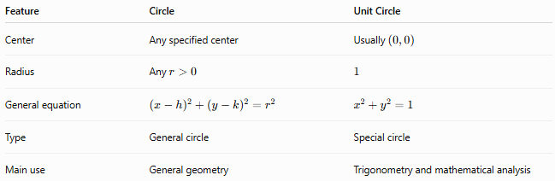
Feature | Circle | Unit Circle
Center | Any specified center | Usually $\left(0 , 0\right)$
Radius | Any $r>0$ | $$1$$
General equation | $${\left(x-h\right)}^{2}+{\left(y-k\right)}^{2}=r^{2}$$ | $$x^{2}+y^{2}=1$$
Type | General circle | Special circle
Main use | General geometry | Trigonometry and mathematical analysis
Thus:
$$\boxed{\text{Unit Circle is a special type of Circle}}$$

Unit Circle vs Unit Disk
# Source: AI Source: Provided by: [Data Path: Persons Table -> ID Column: 1, Name_En Column: Motasem Essam] -> From: [ChatGPT] on [7/25/2026]
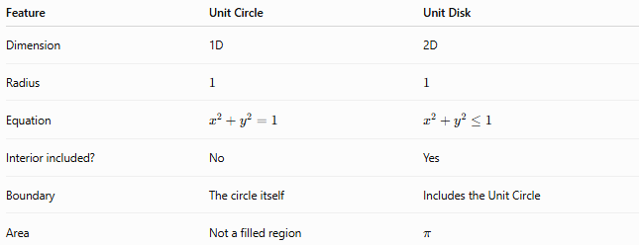
Feature | Unit Circle | Unit Disk
Dimension | 1D | 2D
Radius | $$1$$ | $$1$$
Equation | $$x^{2}+y^{2}=1$$ | $$x^{2}+y^{2}≤1$$
Interior included? | No | Yes
Boundary | The circle itself | Includes the Unit Circle
Area | Not a filled region | $$π$$
Therefore:
$$\boxed{\text{Unit Circle}=\text{Boundary}}$$
while
$$\boxed{\text{Unit Disk}=\text{Interior + Boundary}}$$

Classification Summary
# Source: AI Source: Provided by: [Data Path: Persons Table -> ID Column: 1, Name_En Column: Motasem Essam] -> From: [ChatGPT] on [7/25/2026]
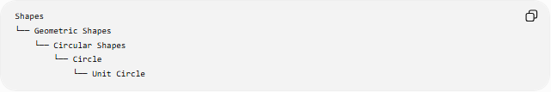
Shapes
└── Geometric Shapes
└── Circular Shapes
└── Circle
└── Unit Circle
The Unit Circle can also be classified by its defining property:
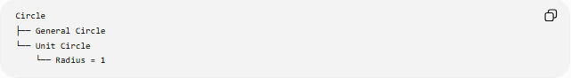
Circle
├── General Circle
└── Unit Circle
└── Radius = 1

Key Points
# Source: AI Source: Provided by: [Data Path: Persons Table -> ID Column: 1, Name_En Column: Motasem Essam] -> From: [ChatGPT] on [7/25/2026]
- A Unit Circle has a radius of exactly $1$.
- The standard Unit Circle is centered at $\left(0 , 0\right)$.
- Its equation is:
$$\boxed{x^{2}+y^{2}=1}$$
- A point corresponding to angle $θ$is:
$$\boxed{\left(\cos{θ} , \sin{θ}\right)}$$
- The $x$-coordinate represents cosine.
- The $y$-coordinate represents sine.
- Tangent is:
$$\boxed{\tan{θ}=\frac{y}{x}}$$
- Its circumference is:
$$\boxed{2π}$$
- Its enclosed area is:
$$\boxed{π}$$
- Its arc length for angle $θ$radians is:
$$\boxed{s=θ}$$
- It is fundamental to trigonometry and the relationship between angles, coordinates, and trigonometric functions.
- The Unit Circle is a boundary, whereas the Unit Disk is the corresponding filled region.

Conclusion
# Source: AI Source: Provided by: [Data Path: Persons Table -> ID Column: 1, Name_En Column: Motasem Essam] -> From: [ChatGPT] on [7/25/2026]
The Unit Circle is a special circle with radius $1$, normally centered at the origin. Its equation,
$$\boxed{x^{2}+y^{2}=1}$$
provides the geometric foundation for trigonometry. Every point on the Unit Circle can be expressed as
$$\boxed{\left(\cos{θ} , \sin{θ}\right)}$$
so the $x$- and $y$-coordinates directly give the cosine and sine of the corresponding angle. It also establishes the fundamental identity
$$\boxed{\sin^{2}θ+\cos^{2}θ=1}$$
and provides the natural geometric connection between angles, radians, coordinates, arc lengths, and trigonometric functions.

